

Faculty of Engineering (Degree)
Semester – 1
Subject Name – Programming for Problem Solving
Subject Code – BE200104
Faculty Name – Ashwini Walake
Unit - 7: User-defined Functions

User-Defined Function in C
A user-defined function is a function created by the programmer to perform a specific task. It helps make programs modular, reusable, and easier to maintain.
- User-defined functions are written by the programmer based on the program's requirements.

#include <stdio.h>
// Function definition
void greet()
{
printf("Welcome to C Programming!");
}
int main()
{
// Function call
greet();
return 0;
}
Function prototype :
In C, a function prototype is a statement that tells the compiler about the function’s name, its return type, number of parameters, and data types of its parameters.
Function prototype provides a means for the compiler to cross-check function parameters and their data type with the function definition and the function call.
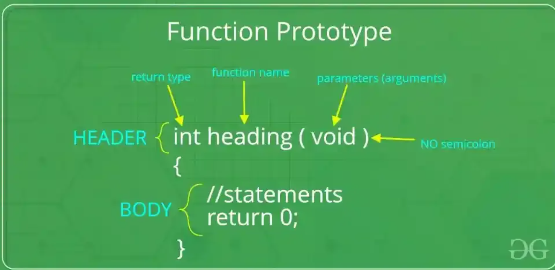
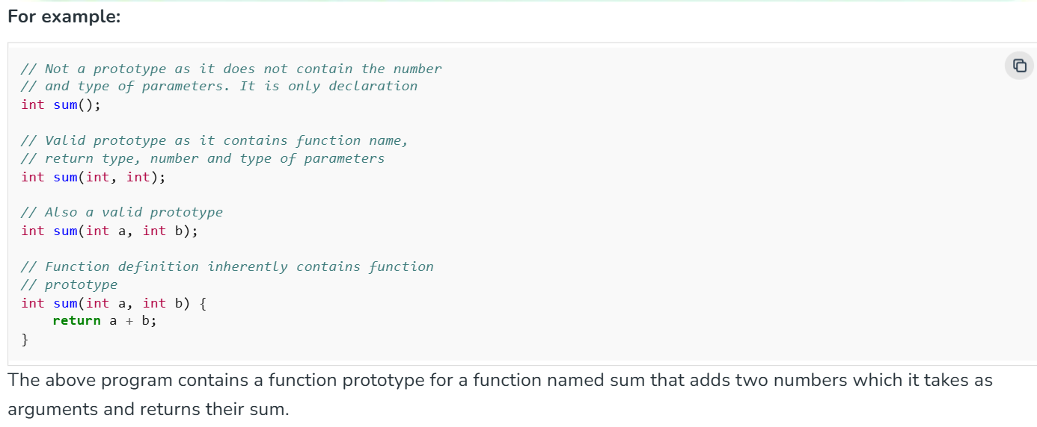
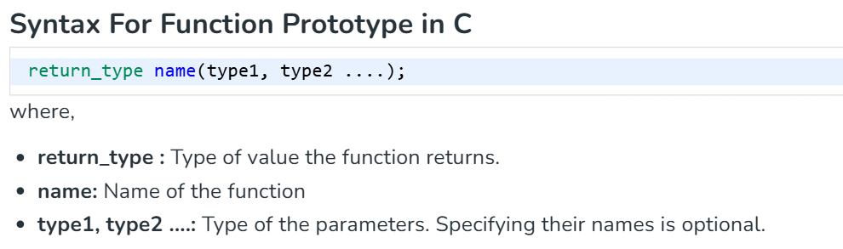
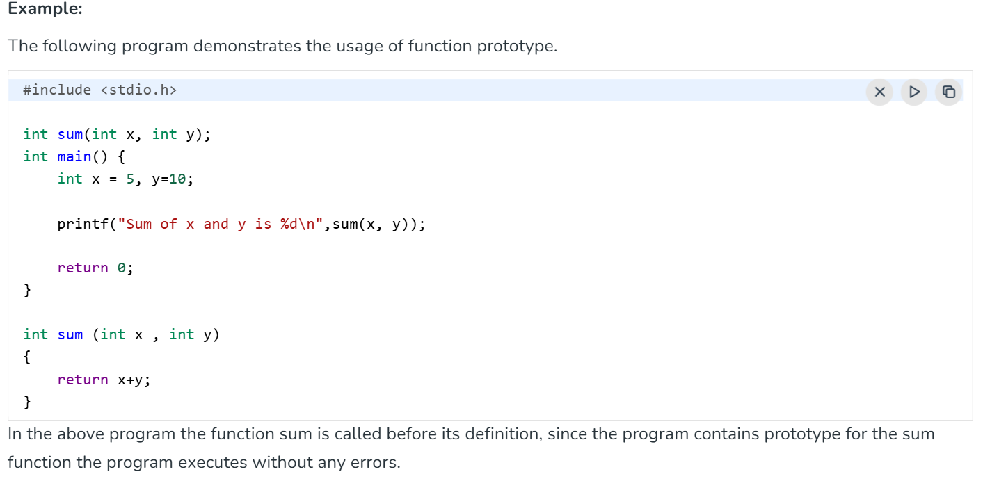
Advantages of Function Prototypes
Following are the major benefits of including function prototypes in your program:
- Function Declaration Before Definition: It allows a function to be called before function definition. In large programs, it is common to place function prototypes at the beginning of the code or in header files, enabling function calls to occur before the function’s actual implementation.
- Type Checking: A function prototype allows the compiler to check that the correct number and type of arguments are passed to the function. If the function is called with the wrong type or number of parameters, the compiler can catch the error.
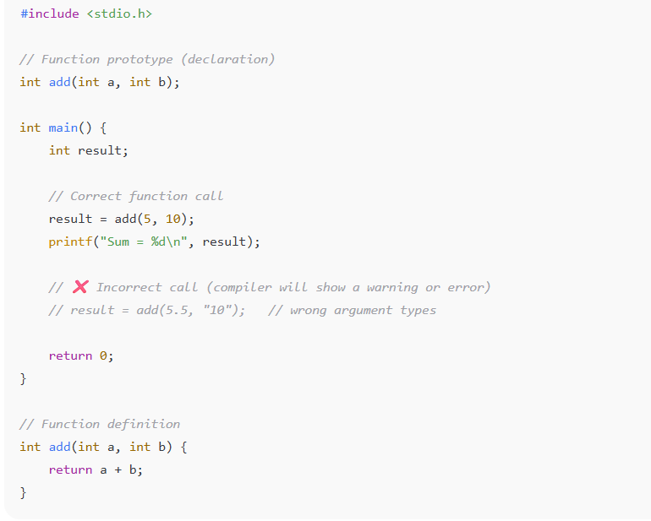
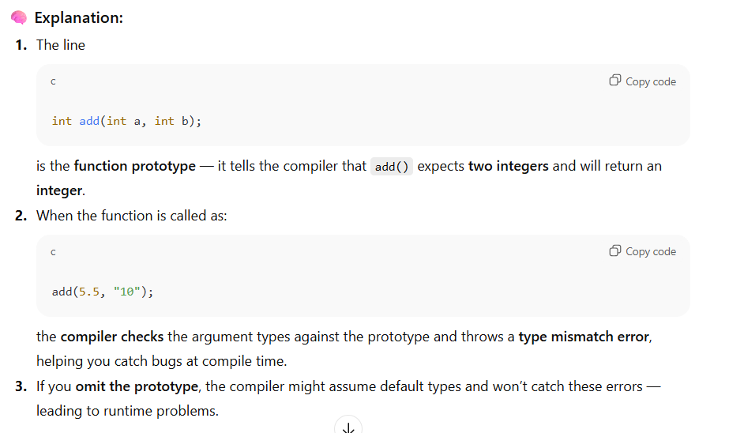
- Code Clarity: By declaring prototypes, you inform the programmer about the function's purpose and expected parameters, which helps in understanding the code structure.
Function definition

C Function Definition
A function definition contains the actual code that specifies what a function does. It includes the function's return type, name, parameters, and a body enclosed within curly braces { }.
- Contains the executable statements that perform the function's task.
- The function body is enclosed within { } braces.
EXAMPLE:
#include <stdio.h>
// Function definition
int add(int a, int b)
{
return a + b;
}

int main()
{
int result = add(10, 20);
printf("Sum = %d", result);

return 0;
}
Output
Sum = 30

Syntax
return_type function_name (type1 arg1, type2 arg2 .... typeN argN) {
// actual statements to be executed
// return value if any
}
Note: If the function call is present after the function definition, we can skip the function prototype part and directly define the function
Function Declaration
A declaration tells the compiler about the function's name, return type, and parameters before it is actually used. It does not contain the function's body. This is often placed at the top of the program or in a header file.
// function declaration
int add(int a, int b);

Function Definition
A definition provides the actual implementation of the function. It includes the full code or logic that runs when the function is called.
int add(int a, int b) {
return a + b;
}

Components of Function Definition
There are three components of the function definition:

1. Function Parameters
Function Parameters (Arguments) are the values passed to a function during a function call. The number, order, and data types of the arguments should match the parameters specified in the function definition.
Syntax:
int foo (int a, int b);
Here, a and b are function parameters.
Note: C language provides a method using which we can pass variable number of arguments to the function. Such functions are called variadic function.

2. Function Body
The function body is the set of statements that are enclosed within { } braces. They are the statements that are executed when the function is called.
Syntax:
int foo (int a, int b) {
int sum = a + b;
return sum;
}
Here, the statements between { and } is function body.

3. Return Value
The return value is the value returned by the function to its caller. A function can only return a single value and it is optional. If no value is to be returned, the return type is defined as void.
The return keyword is used to return the value from a function.
Syntax:
int foo (int a, int b) {
return a + b;
}
Note: We can use pointers or structures to return multiple values from a function in C.

Calling a Function
Once a function is defined, you can use it by simply calling its name followed by parentheses. This tells the program to execute the code inside that function.
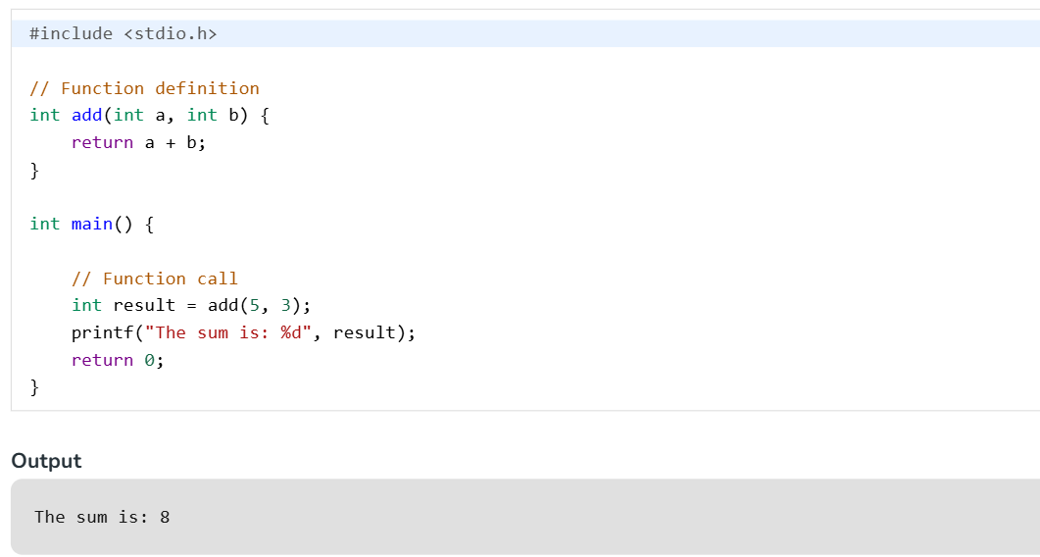
In this example, the function add is called with the values 5 and 3. The function runs its logic (adding the numbers) and returns the result, which is then stored in the variable result.
You can call a function as many times as needed from main or other functions. This helps avoid writing the same code multiple times and keeps your program clean and organized.
Parameter Passing Techniques in C
In C, passing values to a function means providing data to the function when it is called so that the function can use or manipulate that data. Here:
- Formal Parameters: Variables used in parameter list in a function declaration/definition as placeholders. Also called only parameters.
- Actual Parameters: The actual expression or values passed in during a function call. Also called arguments.
There are two main techniques for passing parameters to functions in C:
- Call By Value
- Call By Reference

Call by value
Call by Value is a parameter passing method in which a copy of the actual argument is passed to the function. Any changes made inside the function do not affect the original variable.
- The function works on a copy of the original value.
- Changes made inside the function are not reflected in the calling function.
// C program to show use of
// call by value
#include <stdio.h>
void swap(int a, int b)
{
int temp = a;
a = b;
b = temp;
}
// Driver code
int main()
{
int x = 10, y = 20;
printf("Values of x and y before swap are: %d, %d\n", x,
y);
swap(x, y);
printf("Values of x and y after swap are: %d, %d", x,
y);
return 0;
}
Output
Values of x and y before swap are: 10, 20
Values of x and y after swap are: 10, 20
Note: Values aren't changed in the call by value since they aren't passed by reference.

Call by Reference
Call by Reference is a parameter passing method in which the address of the actual argument is passed to the function using pointers. Any changes made inside the function affect the original variable.
- The function works with the original variable through its address.
- Changes made inside the function are reflected in the calling function.

// C program to implement
// Call by Reference
#include <stdio.h>
void swap(int* a, int* b)
{
int temp = *a;
*a = *b;
*b = temp;
}
// Driver code
int main()
{
int x = 10, y = 20;
printf("Values of x and y before swap are: %d, %d\n", x,
y);
swap(&x, &y);
printf("Values of x and y after swap are: %d, %d", x,
y);
return 0;
}
Output
Values of x and y before swap are: 10, 20
Values of x and y after swap are: 20, 10

Return Type and Return Statement:
The Return Type
The return type is placed right before the function name during definition or declaration. It dictates what the C function will output]
- Standard Data Types: Functions can return standard primitive types like int, float, double, or char. They can also return complex structures like pointers or custom structures (struct).
- Void Type: If a function performs an action (like printing text) but does not need to send data back, its return type is declared as void.
- Implicit Default: If you completely omit a return type, older C standards assume a default type of int, though this is considered dangerous practice in modern engineering
The Return Statement
The return keyword has two primary operations: it immediately stops execution of the current function and transfers execution control back to where the function was called.
1. Functions Returning a Value (Non-Void)
- If a function has a declared return type (e.g., int), it must include a return statement followed by an expression or variable that matches or can convert to that type

int multiplyNumbers(int a, int b) {
return a * b; // Evaluates the math and returns an integer

}2. Functions Not Returning a Value (Void)
For void functions, using a return; statement is completely optional. The function automatically stops when it hits the closing curly brace }. However, an empty return; is helpful if you want to exit a function early due to a condition.
void checkAge(int age) {
if (age < 18) {
printf("Access Denied.\n");
return; // Exits the function early without returning a value
}
printf("Access Granted.\n");
}
Recursive Functions
A recursive function is a function that solves a problem by calling itself on a smaller subproblem. It typically consists of two main parts:
- Base Case – the condition under which the recursion stops.
- Recursive Case – where the function calls itself with modified arguments, gradually approaching the base case.

void checkAge(int age)
{
if (age < 18) { printf("Access Denied.\n"); return; // Exits the function early without returning a value } printf("Access Granted.\n"); }
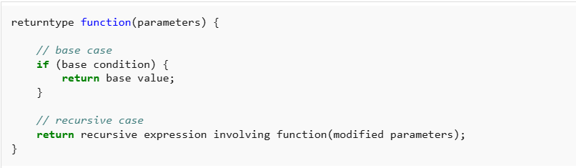
How Recursion works?
To understand how recursion works internally, it’s important to see how the call stack behaves during recursive calls. Each time a function calls itself, the current state is saved on the stack, and the new call begins. Once the base case is reached, the function starts returning back, one call at a time.
The following example demonstrates both the descending phase (going deeper into recursion) and the ascending phase (returning back from recursion):
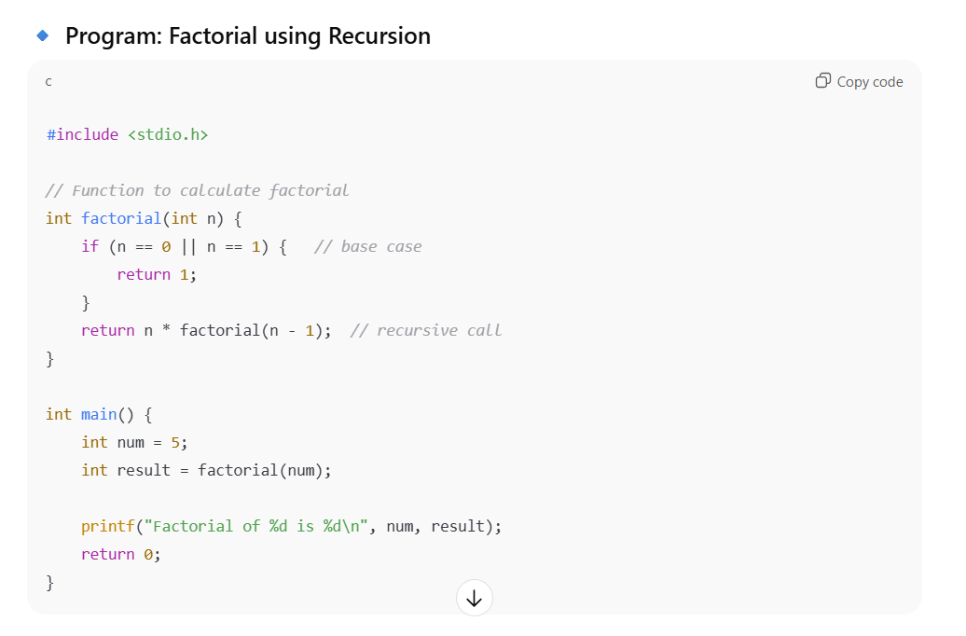
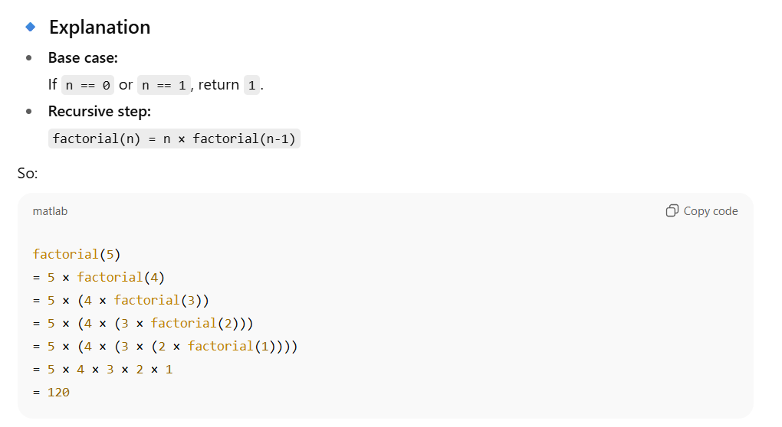
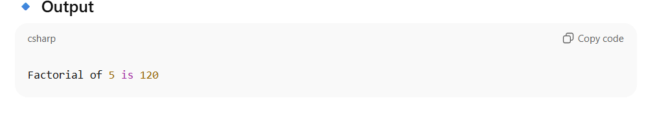
Example
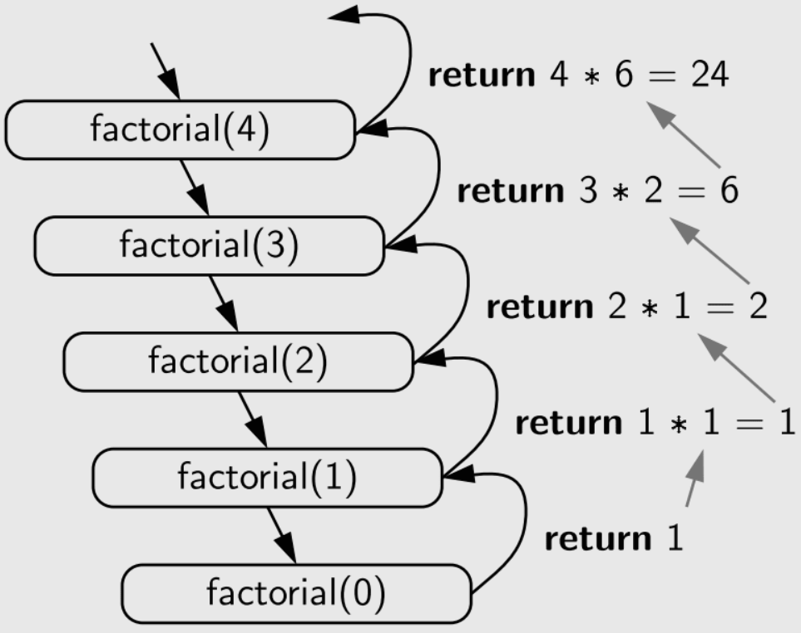

Applications of Recursion
Recursion is widely used to solve different kinds of problems from simple ones like printing linked lists to being extensively used in AI. Some of the common uses of recursion are:
- Tree-Graph Algorithms
- Mathematical Problems
- Divide and Conquer
- Dynamic Programming
- In Postfix to Infix Conversion
- Searching and Sorting Algorithms
Advantages of Recursion
The advantages of using recursive methods over other methods are:
- Recursion can effectively reduce the length of the code.
- Some problems are easily solved by using recursion like the tower of Hanoi and tree traversals.
- Data structures like linked lists, trees, etc. are recursive by nature so recursive methods are easier to implement for these data structures.
Disadvantages of Recursion
As with almost anything in the world, recursion also comes with certain limitations some of which are:
- Recursive functions make our program a bit slower due to function call overhead.
- Recursion functions always take extra space in the function call stack due to separate stack frames.
- Recursion methods are difficult to understand and implement.

Nested Functions in C
Nesting of functions refers to placing the definition of the function inside another functions. In C programming, nested functions are not allowed. We can only define a function globally.
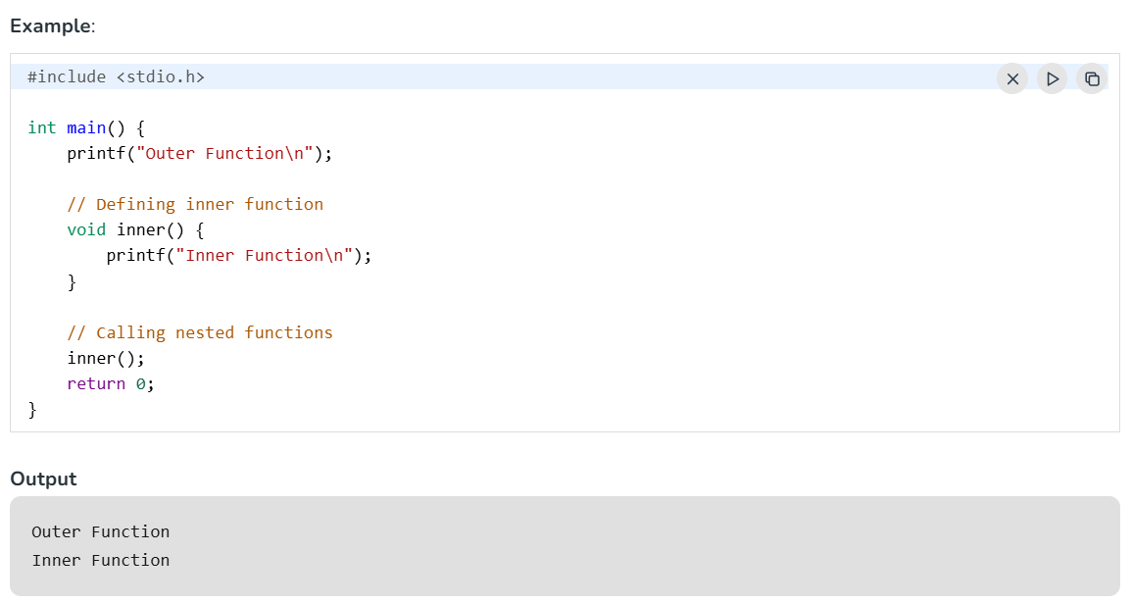
If you want to declare the function before its definition, then use auto keyword.
// Declaring inner function
auto void inner();
Modular programming in C
Modular programming in C is a software design technique where a massive program is broken down into smaller, independent, and reusable building blocks called functions or modules. This "divide and conquer" approach ensures that each module handles exactly one specific aspect of the program's required behavior, transforming unmanageable codebases into clean, readable systems
Core Components of a Function
To implement modularity, you must understand the three steps required to create and use a function in C Function Declaration (Prototype): Tells the compiler the function name, its return data type, and expected parameters. It serves as a blueprint.
- Function Definition: Contains the actual block of code (statements) that executes the intended task.
- Function Call: Invokes the function from somewhere else in the code (such as the main() function) to execute its logic.

#include <stdio.h>
// 1. FUNCTION DECLARATIONS (Prototypes)
int add(int a, int b);
int multiply(int a, int b);
void greetUser(void);

// The primary execution entry point coordinating the modules
int main() {
int num1 = 10, num2 = 5;
int sum_result, product_result;

// 3. FUNCTION CALLS
greetUser();
sum_result = add(num1, num2);
product_result = multiply(num1, num2);

printf("Sum: %d\n", sum_result);
printf("Product: %d\n", product_result);
return 0;
}

// 2. FUNCTION DEFINITIONS
void greetUser(void) {
printf("Welcome to the Modular C Program!\n");
}
int add(int a, int b) {
return a + b; // Returns the processed output to the caller
}

int multiply(int a, int b) {
return a * b;
}
Key Advantages of Modular Design
- Code Reusability: Write a block of logic once and invoke it thousands of times without copy-pasting code.
- Easier Debugging: If a math calculation fails, you only need to investigate the isolated function file rather than scanning the entire program.
- Team Collaboration: Different programmers can develop, test, and maintain separate functional modules simultaneously without stepping on each other's code.
- Enhanced Readability: Isolating complex tasks hides implementation details, allowing anyone reviewing the main() loop to quickly grasp what the code achieves at a macro level.

